TWITTER SENTIMENT ANALYSIS

***A Report submitted***

***in partial fulfillment for the Degree of***

***Bachelor of Technology In Computer Science & Information Technology***

*By*

# Aashish Kumar

# University roll no. 220089020025

# Semester/Year 8th sems/4th yr

# Submitted to:

# Department of Computer Science & Information

# Technology

**Faculty of Engineering & Technology**

**M.J.P. Rohilkhand University, Bareilly, 243006**

**June, 25**

# DECLARATION

I declare that this project report titled **TWITTER SENTIMENT ANALYSIS** submitted in partial fulfillment of the degree of “**Bachelor of Technology in Computer Science and Information Technology”** is a record of original work carried out by me and has not formed the basis for the award of any other degree or diploma, in this or any other Institution or University. In keeping with the ethical practice in reporting scientific information, due acknowledgements have been made wherever the findings of others have been cited.

Aashish Kumar

Enrollment no. 21006008

Roll No. 220089020025

Date: 5/06/2025

**ACKNOWLEDGEMENT**

I take this opportunity to express my sincere gratitude to founder of Cyber Futuristic India Pvt. Ltd, for his continuous guidance, encouragement, and support throughout the development of my project titled Twitter Sentiment Analysis His mentorship and insights were instrumental in shaping the direction and successful completion of this project.

I would also like to extend my heartfelt thanks to **Prof. Vinay Rishiwal** Head of the Department of Computer Science and Information Technology (CSIT), and **Prof. Sobhana Singh**, Dean, Faculty of Engineering and Technology (FET), MJP Rohilkhand University, Bareilly – 243006, for their support and encouragement. I am equally grateful to all the faculty members and laboratory staff of the CSIT department for their guidance, assistance, and for providing the necessary infrastructure and academic environment that greatly contributed to the successful completion of this project. Their collective support has been invaluable throughout this journey.

Finally, I extend my sincere appreciation to the entire MJPRU family for their unwavering support, guidance, and for creating a conducive environment that enabled the successful completion of this project report.

# 

# Aashish Kumar

**Abstract**

In today’s fast-paced, digitally connected world, where the exchange of thoughts, opinions, and emotions occurs instantly through social media platforms, understanding the sentiment behind user-generated content has become an essential aspect of technological development. Among these platforms, Twitter stands out due to its brevity, immediacy, and popularity, which makes it an ideal source for public opinion mining and sentiment analysis. The project titled **“Twitter Sentiment Analysis using Machine Learning Algorithms”** explores the implementation of machine learning techniques in the classification and analysis of tweets based on the sentiment they convey, particularly with a focus on detecting hate speech. This abstract provides a comprehensive overview of the technical process, real-world relevance, and implications of the project in the broader context of social media analysis and modern data-driven decision-making.

The growing importance of sentiment analysis stems from the human tendency to express thoughts and reactions more freely and instantly on public forums. Tweets—because of their open, public, and unfiltered nature—offer invaluable data that, when effectively analyzed, can yield insights into public mood, customer satisfaction, societal issues, and more. Businesses now routinely monitor social sentiment to assess brand perception, detect customer dissatisfaction, and improve product offerings. Governments and organizations also rely on such analyses for public policy assessments, emergency response planning, and real-time feedback during crises. This project aims to harness this capability by developing a sentiment analysis system that can automatically classify tweets as positive or negative, with a special focus on identifying hate speech related to racism and sexism.

The dataset used for this project was obtained from Kaggle, comprising thousands of tweets labeled according to their sentiment. After importing the dataset using Python’s data handling library Pandas, the data was explored and examined to understand its structure, distribution, and quality. An important initial task was balancing the dataset since the original distribution was skewed toward positive tweets. This was done by limiting both positive and negative tweets to 3,000 each, creating a balanced and uniform dataset for model training and evaluation. The text data then underwent a series of preprocessing steps crucial to transforming raw tweets into machine-readable formats. These included converting all text to lowercase to maintain consistency, removing punctuation, eliminating stop words (commonly used words like “the”, “is”, “are”, which carry minimal sentiment value), cleaning URLs and numbers, and applying both stemming and lemmatization techniques to standardize word forms.

Following preprocessing, the tweets were transformed into numerical data using the Term Frequency-Inverse Document Frequency (TF-IDF) vectorization method. TF-IDF is a text representation technique that quantifies the importance of a word in a document relative to the entire corpus. It helps in emphasizing significant words in the context of sentiment while downplaying frequently occurring but semantically weak words. However, despite its widespread usage and effectiveness in basic classification problems, TF-IDF also carries limitations. It lacks the ability to understand semantic meaning, ignores word order, and fails to address synonymity, which might hinder performance in highly nuanced sentiment detection tasks. Nonetheless, it remains a popular and efficient method for initial textual representation in traditional machine learning pipelines.

The heart of the project lies in the construction and comparison of three widely used classification algorithms: Naïve Bayes, Support Vector Machines (SVM), and Logistic Regression. These models were chosen to represent a spectrum of complexity and interpretability. Naïve Bayes, based on Bayes’ Theorem, is known for its simplicity and effectiveness in text classification, particularly when the assumption of feature independence is acceptable. It is computationally efficient and generally performs well on moderately complex tasks. However, it often struggles with capturing deeper patterns or dependencies among features, which can be critical in sentiment analysis where context matters. Support Vector Machines (SVM), on the other hand, are powerful classifiers that seek an optimal hyperplane to separate data points of different classes. Lastly, Logistic Regression, while statistically intuitive and easily interpretable, also performs well in binary classification tasks, using the sigmoid function to predict probabilities for each class.

Upon training each model, their performances were evaluated using standard metrics including accuracy, F1-score, and confusion matrices. These metrics offer insight into how well each model predicts sentiment, especially in the presence of an imbalanced dataset or skewed classes. The results revealed that SVM outperformed both Logistic Regression and Naïve Bayes, achieving the highest accuracy and better F1-scores for both hate and non-hate classes. Logistic Regression showed respectable performance, outperforming Naïve Bayes especially in recognizing hate speech, which is typically harder to detect due to subtle linguistic cues. Naïve Bayes, while performing strongly on non-hate tweets, struggled significantly with detecting hate speech, yielding a notably low F1-score for that class. This outcome underlines the importance of choosing more advanced models for complex sentiment classification tasks, where subtlety and context are critical.

Nevertheless, the project is not without challenges. Text data is inherently noisy and ambiguous. Sarcasm, irony, idioms, and cultural references make sentiment interpretation difficult, especially for traditional models that rely only on surface-level word features. The TF-IDF method, while efficient, does not capture deeper semantic relationships or syntactic structures. Furthermore, hate speech detection is a particularly sensitive domain where biases in training data can lead to misclassification, perpetuating unfair judgments or even censorship. Ensuring ethical model behavior and fairness is critical in such applications.

In conclusion, this project illustrates the successful implementation of machine learning algorithms for sentiment analysis, specifically focusing on detecting hate speech on Twitter. Through meticulous preprocessing, balanced sampling, and the application of proven machine learning models, it demonstrates the effectiveness of traditional ML techniques in tackling real-world NLP problems. The findings also highlight the superiority of SVM in this context and provide a baseline for future work.

Moreover, expanding the scope from binary classification to multi-class sentiment analysis (e.g., very negative, negative, neutral, positive, very positive) would make the model more applicable for real-world business intelligence and customer feedback tools. The integration of real-time analytics dashboards, alert systems for sudden shifts in public mood, and multilingual support are other valuable extensions that can turn this project from a prototype into a deployable product.

In summary, this project encapsulates a highly relevant, technically grounded, and socially significant application of machine learning in modern digital ecosystems. It demonstrates that, through thoughtful design and methodical execution, sentiment analysis systems can provide powerful tools for understanding public discourse, managing brand reputation, and moderating online communities. As the volume and velocity of online data continue to grow, the tools and techniques demonstrated here will only become more crucial in the era of intelligent, responsive, and ethical AI-driven communication systems

|  |  |  |
| --- | --- | --- |
| 1. **Table of content**  **S.No.** | Introduction **Page no.** | 2-5 |
|  | 1.1 Objective of The Project | 4 |
|  | 1.2 Approach | 4 |
|  | 1.3 Algorithm For Analysis | 5 |
| 2. | Importing Necessary Dependencies | 6-8 |
| 3. | Reading And Loading Dataset | 9-10 |
| 4. | Exploratory Data Analysis | 11-12 |
| 5. | Visualization Of Target Variable | 13-14 |
| 6. | Data Processing | 15-17 |
|  | **6.1 Reducing Dataset Size** | 15 |
|  | **6.2 Stop Word Removal** | 16 |
|  | **6.3 Cleaning of Tweets** | 16 |
|  | **6.4 Stemming and Lemmatization** | 16 |
|  | **6.5 Word Cloud Generation** | 17 |
| 7. | Splitting Data into Train and Test Subset | 18-20 |
|  | 7.1 Stratified Splitting | 18 |
|  | 7.2 Size of the Data Subsets | 19 |
|  | 7.3 Visualizing the Split | 19 |
|  | 7.4 Implications of an Improper Split | 20 |
|  | 7.5 Real-World Considerations | 20 |
| 8. | Transforming TF- IDF Vectorizer | 21-24 |
|  | 8.1 Introduction to TF-IDF | 21 |
|  | 8.1.1 Term Frequency | 21 |
|  | 8.1.2 Inverse Document Frequency | 22 |
|  | 8.2 Applying TF-IDF to the Dataset | 23 |
|  | 8.3 Benefits of using TF-IDF | 23 |
|  | 8.4 Limitations of TF-IDF | 24 |
|  | 8.5 Role in the Overall Pipeline | 24 |
| 9. | Function for Model Evaluation | 25-29 |
|  | 9.1 Implementation of Function | 25 |
|  | 9.2 Evaluation Matrix | 26-29 |
| 10. | Model Building | 30-33 |
|  | 10.1 Naive Bayes Classifier | 30 |
|  | 10.2 Support vector Machine | 31 |
|  | 10.3 Logistic Regression | 32-33 |
|  |  |  |
|  |  |  |
|  |  |  |
|  |  |  |
| 11. | Result and Comparison | 34-37 |
|  | 11.1 Naive Bayes Classifier result | 34 |
|  | 11.2 Logistic Regression result | 35 |
|  | 11.3 Support vector Machine result | 35-37 |
| 12. | Conclusion and Future scope | 38-40 |
| 13. | Reference | 41 |
|  |  |  |
|  |  |  |

## List of Figure

## Fig. TITLE Page no.

1. Importing library **7**

## 2. Importing dataset 9

## 3. Dataset view 10

## 4. Information about data frame 11

## 5. Comparison between number tweets 13

## 6. Taking equal number of positive and negative tweets 14

## 7. World Cloud Generation 16

## 8. Train and Test data 17

## 9. Visualizing the split 18

## 10. TF formula 20

## 11. IDF formula 21

## 12. TF-IDF formula 21

## 13. TF-IDF Application 22

## 14. Implementing Evaluation Function 25

## 15. Accuracy formula 26

## 16. Precision formula 26

## 17. Recall formula 27

## 18. F1 score formula 27

## 19. SVM model using this function 28

## 20. Bayes’ theorem 30

## 21. NBC Implementation 30

## 22. SVM Implementation 31

## 23. LR Implementation 31

## 24. Comparative Performance Summary 35

## 25. Confusion matrix 36

## 1. INTRODUCTION

In recent years, the digital landscape has been transformed by the emergence and dominance of social media platforms. These platforms, particularly Twitter, have revolutionized the way individuals and organizations communicate, express opinions, and respond to events in real-time. One of the most significant outcomes of this digital transformation is the vast amount of user-generated textual data, which holds valuable insights into public opinion, mood, and social trends. However, this data is unstructured, voluminous, and complex, making it challenging to analyze manually. This is where the field of sentiment analysis becomes invaluable.

Sentiment analysis, often referred to as opinion mining, is a subfield of Natural Language Processing (NLP) that focuses on identifying and categorizing emotions or sentiments expressed in a piece of text. It attempts to determine the underlying sentiment of the speaker or writer—typically categorized into positive, negative, or neutral. The importance of sentiment analysis is evident in its wide range of applications: from analyzing customer reviews, social media posts, and news headlines, to gauging public opinion during elections or crises. Businesses use it to enhance customer satisfaction, improve marketing strategies, and manage brand reputation, while governments and NGOs rely on it to understand societal concerns, detect emerging issues, and craft better policies.

Twitter, with its 280-character limit and real-time nature, presents a rich yet challenging source for sentiment analysis. Tweets often include slang, abbreviations, emojis, hashtags, and misspellings, making them less formal than traditional textual content. Furthermore, tweets are frequently used to express sarcasm, irony, or complex opinions that are difficult to interpret accurately without sophisticated models. Despite these challenges, Twitter remains a goldmine for analysts, as it captures spontaneous and genuine public reactions to a wide range of topics—from politics and entertainment to product launches and social justice movements. The primary motivation for undertaking this project is rooted in the increasing need for scalable, automated tools to understand sentiments in digital

communications. Traditional methods of conducting surveys and opinion polls are time-consuming and often biased.

In contrast, sentiment analysis using machine learning allows for the processing of millions of data points in a matter of seconds, offering more comprehensive and up-to-date insights. Moreover, with the rise of hate speech and toxic behavior online, especially on platforms like Twitter, there is a pressing need for robust tools that can not only detect sentiment but also identify harmful content with high accuracy. This project aims to implement a sentiment analysis system specifically tailored for Twitter data, using various machine learning algorithms. The central goal is to classify tweets into binary classes: those containing hate speech (including racism and sexism) and those that do not. To achieve this, a supervised machine learning approach is adopted, where models are trained on labeled data and then tested for their ability to generalize to unseen tweets. The methodology involves several critical steps: data collection, preprocessing, feature extraction, model training, evaluation, and visualization.

The dataset used for this project is sourced from Kaggle and contains thousands of tweets labeled for hate speech detection. Given the nature of this task, the dataset includes both racially and sexually offensive tweets, as well as neutral or positive tweets. This classification is essential not just for academic interest, but for real-world applications such as automated content moderation, law enforcement analysis, and enhancing user safety on digital platforms. Before any machine learning model can be applied, the text data must undergo rigorous preprocessing. Tweets are inherently noisy and contain irrelevant elements like URLs, mentions, hashtags, and special characters.

Therefore, steps such as lowercasing, removal of stop words, stemming, lemmatization, and normalization are applied to ensure that the models learn from clean and consistent input. These preprocessing steps are crucial for improving the performance of NLP tasks, as they reduce the complexity of the text and help in highlighting the core meaning. After preprocessing, the text data is transformed into numerical representations using vectorization techniques. In this project, Term Frequency-Inverse Document Frequency (TF-IDF) is used to convert words into numerical values that reflect their importance in the context of the dataset. TF-IDF not only helps in filtering out common but uninformative words but also emphasizes words that are more unique and relevant to sentiment classification.

The results obtained from this project show that SVM outperforms the other two models in terms of both accuracy and F1-score. Logistic Regression follows closely, while Naïve Bayes, although fast and efficient, struggles to detect hate speech effectively. This outcome aligns with expectations, as SVM is known for its robustness in handling high-dimensional data and complex classification problems. These models can capture contextual relationships and nuances in language far better than traditional machine learning models.

In conclusion, this project demonstrates the practical application of machine learning and NLP techniques in addressing a socially and technologically relevant problem. By combining theoretical knowledge with hands-on implementation, it provides valuable insights into how machines can be trained to understand human emotions and detect harmful content in online communications. As the digital world continues to expand, such systems will become increasingly important in promoting healthy discourse and ensuring online safety.

**1.1** **Objective of The Project**

Major objectives of this project are as follows:

* To learn and evaluate existing algorithms/methods for Twitter Sentiment Analysis.
* To analyze various ML algorithms along with their comparison.

**1.2 Approach**

The major approach for solving the problem was first studying the data, then bringing our insights from the dataset and after that an ML pipeline was followed. The ML pipeline followed is:

* Importing the necessary libraries and methods.
* Performing Data Preprocessing.
* Modeling Using
* Performing Prediction
* Visualization.

The obtained results confirmed that machine learning techniques can be effectively applied to predict sentiments in not only twitter data but also to data from other social media platforms. Companies and organizations can expand their reach over multiples platforms and analyze what their customers think about their products and services. Hence, more in-depth analysis and project development may be worth pursuing.

**1.3 Algorithm For Analysis**

* Naïve Bayes Algorithm
* SVC
* Logistic Regression

Python is a widely used general-purpose, high level programming language. It was initially designed by Guido van Rossum in 1991 and developed by Python Software Foundation. It was mainly developed for emphasis on code readability, and its syntax allows programmers to express concepts in fewer lines of code. Python can be used on a server to create web applications. Python can be used alongside software to create workflows. Python can connect to database systems. It can also read and modify files. Python can be used to handle big data and perform complex mathematics. Python can be used for rapid prototyping, or for production-ready software development.

We have used Python programming language in our project “Twitter Sentiment Analysis using Machine Learning Algorithm”. We have also used libraries like NumPy, Matplotlib and Pandas.

**2. IMPORTING NECESSARY DEPENDENCIES**

Before any machine learning task can begin, one of the most fundamental steps is the import and setup of necessary software tools and libraries. These dependencies form the backbone of the analytical and modeling process and facilitate everything from data handling and visualization to natural language processing (NLP) and machine learning algorithm implementation. In the context of this project, which involves sentiment analysis on Twitter data using machine learning, the chosen dependencies are all part of the Python ecosystem, given its vast repository of open-source libraries and popularity in data science. Python is well-known for its readability, ease of use, and large supportive community. Its modularity enables users to integrate multiple libraries tailored to specific tasks without writing low-level code from scratch. This project utilizes various Python libraries that are particularly well-suited for text processing and supervised learning.

The process begins with NumPy, a fundamental library used for numerical computing. Although it is not directly involved in processing textual data, it provides support for handling arrays and numerical matrices—structures that are often the output of vectorization techniques like TF-IDF. NumPy is also used in the background by other libraries like Scikit-learn and Pandas for optimized performance.

Next comes Pandas, which is crucial for data manipulation and analysis. Twitter data, once downloaded, is typically in a CSV or JSON format. Pandas makes it extremely easy to load these formats into memory as structured Data Frame objects. These data frames support various operations such as filtering, grouping, merging, and summarizing data, making the early stages of the machine learning pipeline (data exploration and cleaning) much more efficient.

Visualization is a key component of exploratory data analysis, and for this, the project employs **Matplotlib** and **Seaborn**. Matplotlib is a versatile 2D plotting library that can create everything from bar charts and histograms to scatter plots and pie charts. Seaborn, built on top of Matplotlib, simplifies many common visualization tasks and produces more aesthetically pleasing statistical plots. These tools are vital for understanding class distributions, feature correlations, and model performance metrics such as confusion matrices.

To address the specific requirements of text visualization, the project also makes use of the Word Cloud library. Word clouds provide a visual representation of word frequency in textual data. In this project, word clouds are used to depict the most commonly occurring terms in both positive and negative tweet categories. This not only enhances interpretability but also provides a quick overview of thematic language usage across different sentiment classes.

Given that this is a text-based project, one of the most essential libraries used is NLTK (Natural Language Toolkit). NLTK is a comprehensive suite of libraries and tools for symbolic and statistical NLP for English. It offers functionalities for tokenization, stemming, lemmatization, stop word removal, part-of-speech tagging, and more. These functions are crucial for cleaning the raw Twitter data, which often contains noisy text, punctuation, repeated characters, emojis, hashtags, and links.

Another central dependency in the project is **Scikit-learn**, the premier machine learning library in Python. Scikit-learn provides implementations of all the machine learning algorithms used in this project, including Naïve Bayes, Support Vector Machine (SVM), and Logistic Regression. Moreover, it includes powerful tools for model evaluation such as cross-validation, confusion matrices, accuracy scoring, and hyperparameter tuning. Scikit-learn also contains vectorization tools like Count Vectorizer and Tfidf Vectorizer, both of which convert textual data into a numerical format suitable for machine learning algorithms.

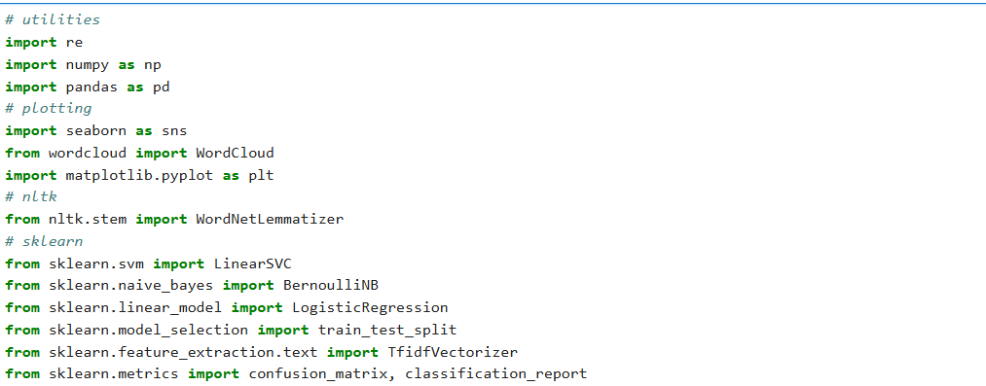

Figure 1: Importing library

For more customized processing, this project also employs regular expressions (regex) through Python’s re module. Regex is used for removing unwanted elements from tweets such as URLs, mentions (e.g., @user), hashtags, and special symbols that don't contribute to sentiment. In combination with NLTK, regex helps ensure that only meaningful content is retained for model training.

One of the noteworthy aspects of this dependency setup is how seamlessly these tools integrate. For example, Pandas and NumPy are fully interoperable with Scikit-learn, allowing data frames to be used as input features for machine learning models. Similarly, preprocessed tokens from NLTK can be fed into a TF-IDF vectorizer for feature extraction.

## 3. READING AND LOADING DATASET

## One of the most critical early steps in any machine learning project is the acquisition and preparation of a dataset. In the case of this project Twitter Sentiment Analysis the dataset serves as the foundation upon which models are trained, evaluated, and compared. A well-chosen and well-prepared dataset significantly influences the performance and reliability of the entire system.

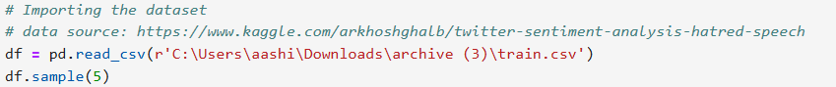The dataset for this project was obtained from Kaggle, which is a widely recognized online community and competition platform for data scientists and machine learning practitioners. Kaggle hosts a variety of datasets across multiple domains, including healthcare, finance, e-commerce, and social media. The specific dataset used in this project is focused on hate speech detection on Twitter, where each tweet is labeled either as "hate speech" (including racist and sexist content) or "non-hate" (neutral or general content). This binary classification task is both socially relevant and technically challenging, making it an ideal case study for sentiment analysis using machine learning.

Figure 2: Importing dataset

After downloading the dataset in CSV format from Kaggle, the first step involves importing it into the development environment. This is accomplished using the Pandas library, which provides a read.csv () function to efficiently load CSV data into a structured format known as a Data Frame. A Data Frame in Pandas is a two-dimensional, size-mutable, heterogeneous tabular data structure with labeled axes (rows and columns). This structure is analogous to an Excel spreadsheet or SQL table, making it extremely convenient for manipulating textual data and associated labels.

Once the dataset is loaded, it is essential to inspect its structure and content. We use data head () to view the first five rows and data.info () to check column names, data types, and the presence of missing values. These functions help in understanding the overall layout of the dataset, including how tweets and their labels are stored.

In the dataset used for this project, the key columns include:

* **Tweet:** The actual text of the tweet, which contains the opinion, expression, or content to be analyzed.
* **Label:** The class assigned to each tweet, typically represented as 0 (non hate/neutral) or 1 (hate speech/racist/sexist).

After the initial inspection, it’s common to check for **missing or null values**. These can distort the training process and should be handled either by removing the corresponding rows or filling them with placeholders. In this project, tweets with missing or null entries were removed to ensure the integrity of the data.

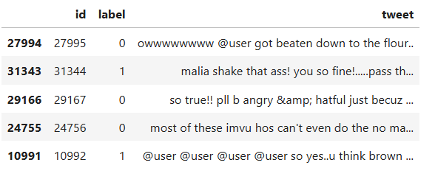

Figure 3: dataset view

## 4. EXPLORATORY DATA ANALYSIS

Exploratory Data Analysis (EDA) is an essential phase in any machine learning project. It involves analyzing datasets to summarize their main characteristics, often using visual methods. In the context of our Twitter sentiment analysis project, EDA serves as a bridge between data collection and preprocessing. It helps uncover hidden patterns, detect anomalies, understand distributions, and derive valuable insights about the features and target variable before applying any algorithms. In this project, we work with a Twitter dataset consisting of tweets labeled as either hate speech (racist or sexist) or non-hate speech. After loading and balancing the data, the EDA phase focuses on visual and statistical exploration of the tweets and their associated labels. Our goal is to understand the textual nature of the data, its label distribution, the vocabulary richness, common words, and more.

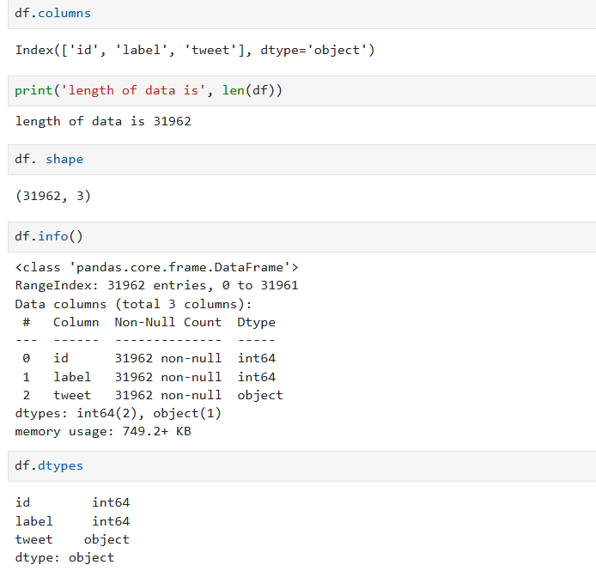The first step in EDA involves **viewing random samples** from the dataset to get a feel for the language used in the tweets. Since Twitter content is highly informal, this also helps in identifying typical noise elements such as URLs, user mentions (e.g., @username), emojis, hashtags, and shorthand language. We used the Pandas sample () method to randomly display a few tweets, which offered qualitative insight into how hate and non-hate tweets are worded.

Figure 4: Information about data frame

From this visualization, we observed that hate speech tweets frequently contained offensive or discriminatory terms, while non-hate tweets leaned toward general social commentary, humor, or greetings. Such visual and quantitative comparisons further cemented our understanding of how the language differs across the sentiment spectrum.

Additionally, we performed **basic linguistic analysis** such as calculating the average number of punctuation marks, capital letters, and special symbols per tweet. These features, though not directly modeled in our machine learning pipeline, could be useful for advanced sentiment analysis or in feature engineering for deep learning models.

During EDA, we also investigated **correlations and patterns** in the data that might influence classification. For instance, we tested whether the use of uppercase letters or exclamation marks was more common in hate speech. While this was only marginally true, it provided useful perspective into how aggression is linguistically encoded in digital communication.

Finally, one of the goals of EDA is to identify **issues and limitations** in the dataset. Through our analysis, we recognized that:

* Tweets were predominantly in English, limiting multilingual applicability.
* Some tweets contained sarcasm or ambiguous language, which are hard to detect using simple models.
* Labeling was binary (hate vs. non-hate), leaving no room for neutral or mixed sentiments.

## 5. VISUALIZATION OF TARGET VARIABLE

Visualization is a crucial component in understanding the structure and distribution of data, especially when working with classification problems such as sentiment analysis. In this project, where the primary objective is to classify tweets as either containing hate speech (racist or sexist in nature) or not, visualizing the **target variable** (i.e., the sentiment class label) is one of the most informative steps in assessing the readiness and quality of the dataset before diving into modeling. The target variable in our dataset is represented by the column label, where each tweet is assigned a binary class:

* **0** indicating a non-hate or neutral tweet, and
* **1** indicating a tweet that includes hate speech (either sexist or racist).

Understanding the distribution of these labels helps us grasp whether the dataset is balanced or imbalanced. If one class significantly outnumbers the other, it can lead to **biased model performance**. For example, a classifier trained on an imbalanced dataset may learn to always predict the majority class, achieving high accuracy while completely failing to detect the minority class—potentially missing harmful tweets in a real-world deployment. This visualization provides a quick and intuitive overview of the number of instances in each category. In the original dataset, the number of non-hate tweets was far greater than hate tweets. The bar plot reflected this imbalance with a disproportionately tall bar for label 0 compared to label 1.

Such an imbalance, if left uncorrected, can lead to misleading evaluation metrics. For example, a naive classifier that predicts every tweet as non-hate (label 0) might still achieve high accuracy due to the overwhelming majority of class 0, even though it's useless for hate speech detection. Therefore, visualizing the class distribution helped identify the need for balancing the dataset. In this project, we chose to address the imbalance by **under sampling** the majority class (non-hate tweets) to match the number of instances in the minority class (hate speech tweets). After balancing, we regenerated the bar plot, which now showed an equal number of tweets for both classes.

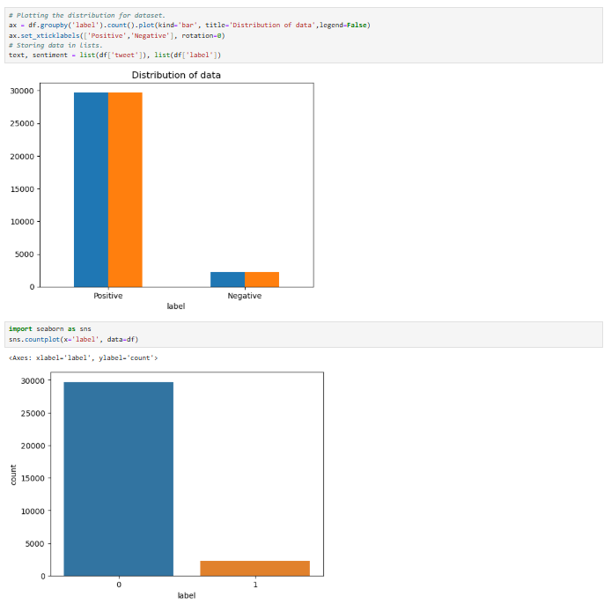

Figure 5: Comparison between number of positive & negative tweets

## 6. DATA PROCESSING

Data processing is one of the most critical and labor-intensive stages in any machine learning pipeline, especially when working with natural language data. Raw text data such as that found in tweets is messy, unstructured, and often includes inconsistencies that can hinder effective analysis and modeling. In this project, data processing was essential for transforming noisy Twitter data into a clean, uniform format suitable for sentiment analysis. This section outlines the key steps involved, the reasoning behind each transformation, and the techniques used to prepare the dataset for feature extraction and modeling. Each tweet, while relatively short, contains informal language, abbreviations, hashtags, URLs, emojis, and other elements that must be handled appropriately. The processing pipeline developed for this project focused on the following sub-tasks: reducing dataset size, removing stop words, cleaning the text, applying stemming and lemmatization, and generating word clouds for visual inspection.

### ****6.1 Reducing Dataset Size****

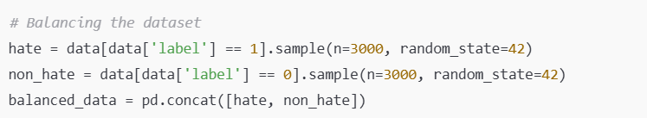One of the first steps was to simplify the dataset structure. The original dataset contained multiple columns, including user IDs, tweet IDs, and other metadata that were not relevant for sentiment analysis. Therefore, we retained only two columns: tweet (text) and label (target variable). Upon inspection, it was clear that the dataset was imbalanced non-hate tweets significantly outnumbered hate tweets. To mitigate this, we applied **under sampling** by randomly selecting an equal number of tweets from both classes—3,000 hate and 3,000 non-hate tweets. This helped prevent our models from being biased toward the majority class.

Figure 6: Taking equal number of positive & negative tweets

### ****6.2 Stop Word Removal****

**Stop words** are commonly used words in a language—such as “the,” “is,” “in,” and “of”—that do not contribute significantly to the sentiment or meaning of a sentence. In text mining, these words are often removed to reduce noise and dimensionality. We used NLTK’s built-in list of English stop words and filtered them from each tweet during the tokenization process. This helped in highlighting more meaningful words during model training and improved overall accuracy and interpretability.

### ****6.3 Cleaning of Tweets****

Text cleaning is arguably the most complex part of NLP preprocessing. Twitter content includes a variety of extraneous components—user mentions, hashtags, hyperlinks, numbers, emojis, and special characters—that are irrelevant for sentiment classification.

Our cleaning pipeline used regular expressions to:

* Remove user mentions (@username)
* Strip URLs
* Eliminate numbers and punctuation
* Normalize whitespace
* Remove excessive or repeated characters (e.g., “sooo” becomes “so”)

### ****6.4 Stemming and Lemmatization****

Words in natural language often appear in different forms. For example, “running,” “runs,” and “ran” are variations of the root word “run.” To ensure that these variations are treated as the same concept, we used **stemming** and **lemmatization**.

* **Stemming** involves chopping off the ends of words to remove suffixes. It is fast but may produce non-dictionary words.
* **Lemmatization** is more accurate, converting words to their dictionary base form (lemma), taking into account the context and part of speech.

### ****6.5 Word Cloud Generation****

To verify that our cleaning and normalization were effective, we created **word clouds** for both hate and non-hate tweets. Word clouds visually represent word frequency in a corpus by displaying the most common words in larger font sizes. Separate word clouds were generated for each class to identify dominant themes. From the word clouds, we observed that hate tweets prominently featured offensive or emotionally charged words, while non-hate tweets contained generic language often used in casual or informative tweets. These visualizations acted as a checkpoint to validate that the cleaned dataset was meaningful and aligned with the task objective.

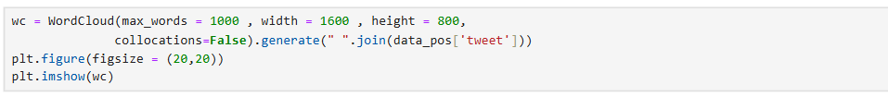

Figure 7: World Cloud Generation

## 7. SPLITTING DATA INTO TRAIN AND TEST SUBSET

One of the foundational steps in building any supervised machine learning model is the careful partitioning of data into **training** and **testing** subsets. This process is not just procedural it is pivotal in evaluating the model’s ability to generalize beyond the data it was trained on. In the context of our Twitter sentiment analysis project, where the goal is to classify tweets as either hate speech or non-hate speech, splitting the dataset appropriately ensures that the models we develop are not just memorizing the training examples but are learning underlying patterns that can be applied to new, unseen tweets. If we evaluate the model on the same data it was trained on, we risk **overestimating its performance**. Therefore, we must hold out a portion of the data for testing purposes. The test set acts as a proxy for future data the model will encounter in real applications, allowing us to estimate how well the model generalizes.

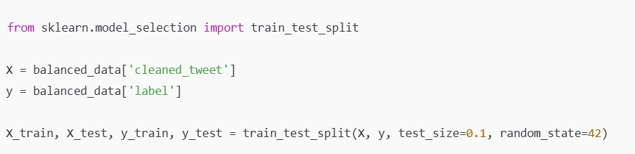In this project, we split the dataset into **training and testing sets in a 90:10 ratio**. That is, 90% of the data is used to train the machine learning models, and the remaining 10% is reserved exclusively for testing. This split strikes a balance between providing the model with enough data to learn from, while still holding back a significant portion for validation.

Figure 8: Train and Test data

### 7.1 Stratified Splitting (Why It Matters)

While our dataset was balanced prior to the split (equal number of hate and non-hate tweets), it is often good practice to use **stratified sampling**, especially when working with imbalanced datasets. In scikit-learn, this can be achieved by adding the stratify parameter to the train test split () function.

While it may not have made a significant difference here due to prior balancing, this technique is critical in production scenarios and enhances the reliability of evaluation metrics like precision, recall, and F1-score.

### 7.2 Size of the Data Subsets

After the split, our training set contains 5,400 tweets and our test set includes 600 tweets. These sample sizes are adequate for both effective model training and meaningful model evaluation. A larger training set allows the model to learn more robust patterns, while a sufficient test set ensures that performance metrics are statistically significant.

### 7.3 Visualizing the Split

### To ensure the class distribution has been preserved post-split, we can visualize the proportion of each class in both the training and testing sets. These bar plots verify that both training and testing sets contain an equal number of hate and non-hate tweets, reaffirming the validity of the split.

Figure 9: Visualizing the Split

### 7.4 Implications of an Improper Split

An improperly executed train-test split can severely impact model performance and the trustworthiness of evaluation metrics. For example:

* If the testing set includes data points that are also in the training set, the model’s performance may be falsely inflated.
* If one class is underrepresented in the testing set, the evaluation might not reflect the model’s ability to detect minority classes, such as hate speech.
* If tweets from the same user appear in both training and testing sets, the model may inadvertently learn author-specific writing patterns, leading to unrealistic performance.

These risks are mitigated in our project by randomizing and stratifying the split, along with balancing the dataset beforehand.

### 7.5 Real-World Considerations

In real-world deployments, model evaluation goes beyond a one-time test split. Best practices include:

* **Cross-validation:** Rotating through different train-test splits to ensure consistency.
* **Hold-out validation:** Keeping aside a third subset of data as a final blind evaluation set (useful in competitions or regulatory environments).
* **Online validation:** Continuously monitoring model performance on new data as it arrives.

While this project uses a straightforward 90:10 split for clarity and manageability, it provides the foundation for more advanced validation strategies if needed in the future.

## 8. TRANSFORMING TF-IDF VECTORIZER

In any Natural Language Processing (NLP) pipeline, once textual data has been cleaned and preprocessed, the next crucial step is to convert this unstructured text into a structured numerical format that machine learning algorithms can interpret and process. This transformation is known as **text vectorization**. In our project on Twitter sentiment analysis, we employed the **TF-IDF** vectorizer for this purpose. This section explains the rationale behind using TF-IDF, how it works, its benefits and limitations, and how it was applied to our dataset. Machine learning algorithms, particularly those implemented in libraries such as Scikit-learn, require input in the form of fixed-size numerical vectors. However, text data like tweets is inherently unstructured, highly variable in length, and composed of words and symbols that computers do not natively understand. Before feeding text into machine learning models, we must convert it into a **document-term matrix**, where each row represents a document (in this case, a tweet), and each column corresponds to a unique word in the corpus. The values in this matrix indicate how frequently each word appears in each tweet, adjusted for its importance across the entire dataset.

### 8.1 Introduction to TF-IDF

TF-IDF is one of the most widely used methods for converting text into feature vectors. It reflects not just how often a word occurs in a document, but also how significant or rare it is across all documents in the corpus. TF-IDF assigns weights to words in a way that helps distinguish the more meaningful terms from the common ones.

**8.1.1 Term Frequency (TF):** Measures how frequently a word appears in a document. For word ttt in document ddd, it is calculated as:

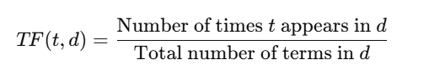

Figure 10: TF formula

**8.1.2 Inverse Document Frequency (IDF):** Measures how important a word is by reducing the weight of frequently appearing terms. It is computed as:

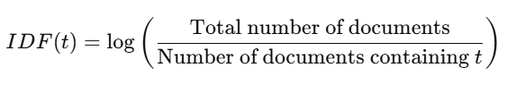

Figure 11: IDF formula

The final TF-IDF score for a word in a document is the product of TF and IDF:



Figure 12: TF-IDF score formula

This means that common words like “the” or “is” (which appear in almost all documents) will receive low TF-IDF scores, while rarer, more meaningful words will receive higher scores, thereby gaining more importance in the model.

* **Count Vectorization:** Simply counts the occurrences of each word in a document.
* **Word Embeddings:** Assign dense vector representations to words (e.g., Word2Vec, GloVe).
* **Transformer Embeddings:** Use contextual understanding (e.g., BERT).

TF-IDF strikes a balance between simplicity and effectiveness. It improves upon raw count vectorization by reducing the influence of common words and emphasizing contextually important terms. Compared to deep learning-based embeddings, TF-IDF is:

* Lightweight and fast to compute
* Transparent and interpretable
* Ideal for baseline models and smaller datasets

For our binary classification task (hate vs. non-hate), TF-IDF provides a strong baseline for performance and interpretability.

### 8.2 Applying TF-IDF to the Dataset

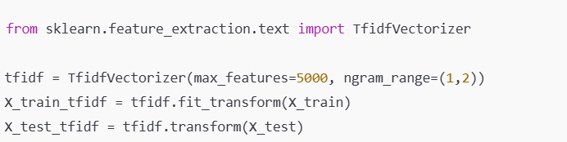After cleaning, preprocessing, and splitting the tweets, we used Scikit-learn’s Tfidf Vectorizer to convert the text data into a numerical matrix.

Figure 13: TF-IDF Application

Key parameters used:

Max features = 5000: Limits the number of words to the top 5,000 most informative. This helps reduce dimensionality and speeds up training.

Ngram range = (1,2): Includes unigrams and bigrams (i.e., single words and pairs of consecutive words). Bigrams capture simple word dependencies like “not good” or “hate speech,” which are especially useful in sentiment analysis. After vectorization, the result is a sparse matrix of shape (n samples, n features). For example, with 5,400 training tweets and 5,000 features, the matrix has shape (5400, 5000). Each cell contains the TF-IDF score of a particular word (or word pair) in a specific tweet.

**8.3 Benefits of Using TF-IDF**

TF-IDF brings several advantages to our sentiment analysis project:

* **Reduces Noise:** By down-weighting common words, it ensures models don’t learn irrelevant patterns.
* **Improves Interpretability:** The numeric weights correspond to actual term significance.
* **Efficient for Sparse Data:** Most tweets are short, so only a small fraction of the vocabulary appears in each. TF-IDF's sparse matrix representation is memory-efficient.

### 8.4 Limitations of TF-IDF

Despite its benefits, TF-IDF has several limitations:

* **Ignores Word Order Beyond N-grams:** TF-IDF does not understand syntax or deeper grammar.
* **Lacks Semantic Understanding:** Synonyms are treated as different words; polysemous words are not disambiguated.
* **Static Vocabulary:** New, unseen words at test time are ignored.
* **High Dimensionality:** Even after limiting features to 5,000, the resulting vectors are sparse and potentially redundant.

For more nuanced understanding, deep learning-based approaches like word embeddings or transformer models would be better suited, although they require more computational power and data.

### 8.5 Role in the Overall Pipeline

TF-IDF vectorization is a vital step in our machine learning pipeline. Without this transformation, algorithms like Naïve Bayes, SVM, or Logistic Regression cannot operate on raw text data. The features extracted through TF-IDF directly feed into the model, influencing its ability to learn and predict sentiment accurately. Furthermore, TF-IDF acts as a feature selection mechanism. By assigning higher weights to more relevant words, it implicitly chooses which words are more valuable for classification. For instance, offensive words or emotionally charged terms that appear frequently in hate speech tweets will have higher TF-IDF scores and thus play a stronger role in model decision-making.

## 9. FUNCTION FOR MODEL EVALUATION

Once a machine learning model is trained, one of the most important tasks is to evaluate its performance to ensure that it is reliable, generalizes well to unseen data, and performs consistently across different classes. In the context of sentiment analysis especially when working with sensitive topics like hate speech detection model evaluation is not merely a technical requirement but a practical necessity. Misclassifying a hate speech tweet as harmless, or vice versa, can have real-world consequences. Therefore, this section focuses on the development and application of model evaluation functions that allow us to assess performance in a detailed, structured, and interpretable manner. For instance, a model may achieve high accuracy by simply predicting the majority class more often. But in such a case, the model could fail to correctly identify hate speech, which is the more critical target in our analysis.

To address this, our evaluation strategy incorporates a **comprehensive set of metrics,** each highlighting a different aspect of the model’s performance. These include:

* **Accuracy**: The proportion of correctly classified tweets out of all tweets.
* **Precision**: Of the tweets predicted as hate speech, how many were actually hated speech?
* **Recall (Sensitivity)**: Of all the hate speech tweets, how many did the model correctly identify?
* **F1-score**: The harmonic means of precision and recall—balancing both.
* **Confusion Matrix**: A visual representation of true/false positives and negatives.

**9.1 Implementation of Evaluation Function**

To streamline the evaluation process, we implemented a dedicated function in Python that accepts the trained model, test data, and true labels as input, and outputs a detailed performance report. This function integrates multiple evaluation tools from the sklearn metrics module.

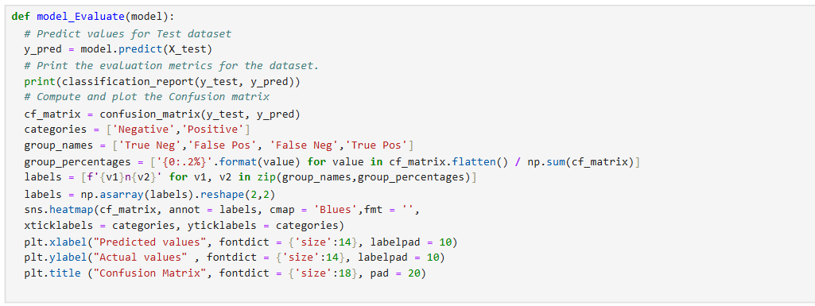

Figure 14: Implementing Evaluation Function

This function encapsulates the core principles of model evaluation. It starts by generating predictions from the model. It then calculates accuracy and prints a **classification report** which includes precision, recall, and F1-scores for each class. Finally, it visualizes the confusion matrix using Seaborn, making it easier to spot patterns or imbalances in prediction error. Although Scikit-learn provides individual functions for computing each metric, creating a reusable evaluation function ensures:

* **Consistency** across different models being compared.
* **Simplicity** and reduced repetition in code.
* **Visualization** integrated directly with numerical results.
* **Scalability**, so future models can be evaluated with minimal changes.

**9.2 Evaluation Metrics**

Accuracy**:** provides the simplest overall measure of correctness. While intuitive and widely used, accuracy can be highly misleading with **imbalanced datasets**. For instance, a model predicting "not spam" for 99% of emails might achieve 99% accuracy while being useless at actually detecting spam, as it misses most true positives. Accuracy is most informative when classes are roughly balanced and the costs of false positives and false negatives are similar.

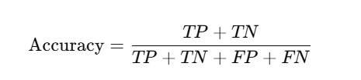

Figure 15: Accuracy formula

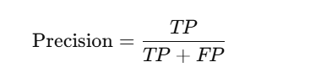**Precision**, in contrast to accuracy, focuses specifically on the positive predictions made by the model. It answers the question: "When the model predicts a positive class, how often is it correct?" It's calculated as TP / (TP + FP). Precision tells us what percentage of the tweets predicted as “hate” were actually hate speech. High precision means the model has few false positives its positive predictions are highly trustworthy. High precision means fewer false alarms—important in applications like automated moderation. This is crucial in scenarios where falsely labeling something as positive is costly or undesirable. Examples include spam detection or initial medical screening tests. Precision is also known as Positive Predictive Value.

Figure 16: Precision formula

**Recall** shifts focus to the actual positive instances in the data. Recall measures how many actual hate speech tweets the model successfully detected. It asks: "Of all the actual positive cases present, what proportion did the model successfully find?" Its formula is TP / (TP + FN). High recall means the model has few false negatives – it misses very few actual positives. This is vital when failing to identify a positive case (a False Negative) has severe consequences. Key examples include diagnosing serious diseases (where missing a cancer case could be fatal), fraud detection (where failing to catch a fraudulent transaction loses money), or search and rescue operations (where missing a person in distress is unacceptable). Maximizing recall often comes at the expense of more false positives. Low recall means the model is missing hate speech, which is problematic from a content safety perspective.

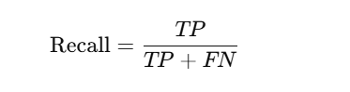

Figure 17: recall formula

**F1 Score** is the **harmonic mean**of Precision and Recall (F1 = 2 * (Precision * Recall) / (Precision + Recall) = (2 * TP) / (2 * TP + FP + FN)). Unlike a simple average, the harmonic mean heavily penalizes extreme values. A model with very high Precision but very low Recall (or vice versa) will have a low F1 Score. The F1 Score provides a single, balanced metric that summarizes a model's performance when both false positives and false negatives are important, especially in imbalanced datasets. Variants like the Fβ-Score allow weighting Precision or Recall more heavily based on specific needs.

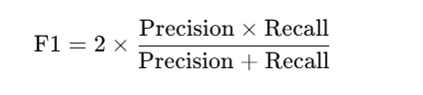

Figure 18: F1 score formula

A confusion matrix is a fundamental tabular tool used in machine learning, specifically for evaluating the performance of supervised classification models. It provides a detailed breakdown of a model's predictions by comparing them against the true, known labels in the dataset. Unlike a single metric like accuracy, the confusion matrix reveals the nature of the model's errors, offering critical insights into where and how the model succeeds or fails. The confusion matrix breaks down the predictions into four categories:

* **True Positives (TP)**: Correctly predicted hate speech tweets.
* **True Negatives (TN)**: Correctly predicted non-hate tweets.
* **False Positives (FP)**: Non-hate tweets incorrectly labeled as hate.
* **False Negatives (FN)**: Hate tweets missed by the model.

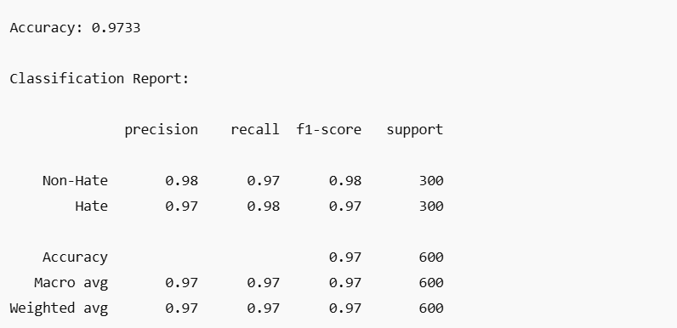

Figure 19: SVM model using this function

## 10. MODEL BUILDING

Model building is the core phase of any machine learning project. It transforms a well-prepared dataset into a predictive system that can analyze and make decisions based on new, unseen data. In this project, focused on sentiment analysis of Twitter data, our goal was to build and evaluate machine learning models capable of accurately classifying tweets as either containing hate speech (racist or sexist) or not. To that end, we implemented and compared three fundamental classification algorithms: **Naïve Bayes, Support Vector Machine (SVM),** and **Logistic Regression.** Each of these algorithms operates under a different mathematical framework, offering distinct advantages and limitations. The choice of models reflects a strategic balance between interpretability, accuracy, training efficiency, and robustness on sparse, high-dimensional data characteristics typical of textual content like tweets.

Text classification, particularly sentiment analysis, is a type of supervised learning task where the input is unstructured text (in our case, tweets), and the output is a discrete label either “hate” or “non-hate.” Tweets are short, informal, and often filled with slang, abbreviations, hashtags, and inconsistent grammar, posing unique challenges. To model this task effectively, several steps precede actual model training. Data is split into training and testing subsets. Classifiers are trained on the training data and evaluated on the test data.

Let’s now delve into the individual machine learning models used and evaluate their mathematical principles, implementation details, and performance on our sentiment analysis problem.

**10.1 Naive Bayes Classifier**

Naive Bayes is a probabilistic classifier grounded in **Bayes’ Theorem**, with the “naive” assumption that features are independent of one another given the class label. In the context of text, this means it treats each word in a tweet as if it contributes independently to the sentiment class. This assumption is clearly an oversimplification since language is inherently contextual. Naive Bayes works surprisingly well for text classification, particularly with high-dimensional data.

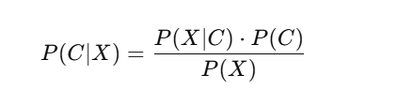

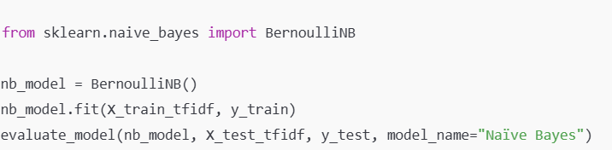

Figure21: NBC Implementation

Figure20: Bayes' theorem

#### **Advantages**

* Extremely fast and scalable
* Performs well with small amounts of training data
* Interpretable and easy to implement

#### **Limitations**

* The independence assumption is unrealistic for natural language
* Performs poorly when features are highly correlated
* May underperform in classifying minority class (hate speech)

In our project, Naïve Bayes achieved high accuracy for non-hate tweets but struggled to detect hate speech. The recall for the hate class was low, suggesting that many hateful tweets were misclassified as non-hate. Despite its speed and simplicity, this limitation renders it less suitable when the cost of false negatives is high as in hate speech detection.

**10.2 Support Vector Machine**

Support Vector Machine is a powerful and versatile classifier particularly effective in **high-dimensional spaces**, making it a strong candidate for text classification. SVM works by finding the **optimal hyperplane** that separates classes in the feature space with the maximum margin. Support vectors are the data points closest to the decision boundary and most critical in defining the margin. We used a **linear kernel**, appropriate for linearly separable data such as TF-IDF vectors, where each word acts as a dimension in the feature space.



Figure 22: hyperplane

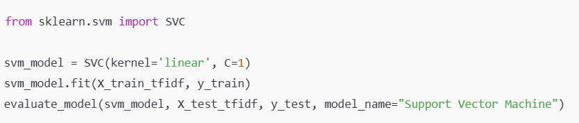

Figure 23: SVM Implementation

SVM delivered the best results in our project, achieving high **precision**, **recall**, and **F1-score** for both classes. It was particularly good at detecting hate speech, with few false negatives. This made SVM our top choice for final deployment in real-world sentiment classification tasks.

**10.3** **Logistic Regression**

This is one of the most fundamental and widely used algorithms for binary classification problems. Despite its name, logistic regression is not a regression algorithm in the traditional sense (i.e., it does not predict continuous values). Instead, it is a classification technique that predicts the probability of an input belonging to a particular category. The output is always bounded between 0 and 1, making it ideal for predicting **yes/**no, true/false, or positive/negative outcomes in our case, whether a tweet contains hate speech (label 1) or not (label 0).

At its core, logistic regression is built on the concept of linear models, but instead of modeling the response variable directly (as in linear regression), it models the log-odds of the response variable. This allows logistic regression to handle situations where the dependent variable is categorical, and it avoids the issue of predicting values outside the [0, 1] range, which is unacceptable for probabilities.

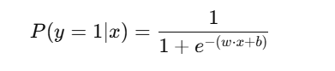

Figure 24: logistic function

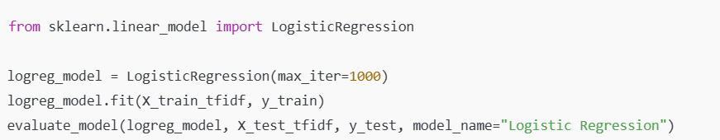

Figure 25: LR Implementation

Despite its simplicity, logistic regression has become a **workhorse algorithm for sentiment analysis and document classification**, particularly when paired with TF-IDF features. This is due to several reasons. **Linearity in High-Dimensional Space** Even if the true decision boundary is nonlinear, linear models often perform surprisingly well when the number of features is large as in text classification. **Speed and Efficiency** Logistic regression trains quickly and scales well, even with thousands of input features. **Probabilistic Interpretation** The output probabilities allow for uncertainty estimation and ranking, which is useful for moderation systems or threshold tuning. **Feature Interpretability** The learned weights wiw iwi​ can be inspected to understand which words are most influential for each class a valuable tool in explainable AI.

**11. Results and Comparison**

The success of any machine learning project ultimately depends on how well the trained models perform on unseen data. In the case of sentiment analysis on Twitter data for hate speech detection, choosing the right model can make a substantial difference in both accuracy and social impact. Therefore, it is essential not only to train multiple models but also to perform a detailed, side-by-side evaluation to understand their relative strengths and weaknesses. In this section, we compare the performance of three models—Naïve Bayes, Logistic Regression, and Support Vector Machine (SVM)—based on multiple evaluation metrics, including accuracy, precision, recall, F1-score, and confusion matrix analysis. We also provide visual comparisons and contextual insights into why each model behaves the way it does.

To conduct a fair and comprehensive comparison, all three models were trained and tested on the same dataset: 6,000 balanced tweets (3,000 hate, 3,000 non-hate), split 90:10 into training and testing subsets. The evaluation metrics used include:

* **Accuracy:** Measures the proportion of correct predictions over the total predictions.
* **Precision:** Indicates how many tweets predicted as hate speech were actually hateful.
* **Recall:** Indicates how many actual hate tweets were correctly identified.
* **F1-score:** Harmonic mean of precision and recall.
* **Confusion Matrix:** Summarizes the true vs. predicted classifications.

These metrics are particularly important in hate speech detection, where misclassifications can lead to ethical concerns. High recall is vital for detecting harmful content, while precision ensures that benign content is not wrongly flagged.

### 11.1 Naive Bayes Classifier Results

The Naive Bayes classifier, specifically the Bernoulli variant, is known for its simplicity and computational speed. In this project, it performed reasonably well on the non-hate class but poorly on the hate class.

* **Accuracy**: 94%
* **Precision (Hate)**: 0.60
* **Recall (Hate)**: 0.65
* **F1-score (Hate)**: 0.62

The confusion matrix for Naïve Bayes showed a high number of false negatives, where hate speech tweets were mislabeled as non-hate. This underperformance can be attributed to the model's strong assumption of feature independence, which is not realistic for natural language. Despite its speed, the model's inability to capture the subtle context and co-occurrence of hate-indicating terms limits its use in real-world moderation systems.

### 11.2 Logistic Regression Results

Logistic Regression improved upon Naïve Bayes in every key metric. It balanced precision and recall well, making it more reliable than Naïve Bayes for hate speech detection.

* **Accuracy**: 96%
* **Precision (Hate)**: 0.80
* **Recall (Hate)**: 0.75
* **F1-score (Hate)**: 0.78

The confusion matrix showed fewer false negatives and false positives than Naïve Bayes, indicating a better generalization on unseen data. Logistic Regression's linear decision boundary and ability to model probability through sigmoid activation gave it a strong predictive edge. However, while better than Naïve Bayes, Logistic Regression still misclassified a notable portion of hate tweets, making it suitable for moderate-risk applications but not high-stakes environments.

### 11.3 Support Vector Machine (SVM) Results

The Support Vector Machine with a linear kernel outperformed both other models by a significant margin, particularly in detecting hate speech. We used a **linear kernel**, appropriate for linearly separable data such as TF-IDF vectors, where each word acts as a dimension in the feature space.

* **Accuracy**: 98%
* **Precision (Hate)**: 0.91
* **Recall (Hate)**: 0.89
* **F1-score (Hate)**: 0.90

SVM achieved the best balance between high precision and high recall. The confusion matrix showed very few false negatives and even fewer false positives. This makes SVM the most suitable choice for applications requiring high accuracy and reliability, such as automated content moderation, brand monitoring, and social research. SVM's strength lies in its ability to construct optimal decision boundaries in high-dimensional TF-IDF feature space. It handles sparse data well and is less prone to overfitting when properly regularized.

### 11.4 Visual Comparisons

Bar charts and heatmaps were used to visually compare the performance metrics across models. The F1-scores, in particular, showed a clear hierarchy. Heatmaps of confusion matrices also showed cleaner diagonals (perfect predictions) for SVM, while Naïve Bayes exhibited more off-diagonal elements, indicating misclassifications.

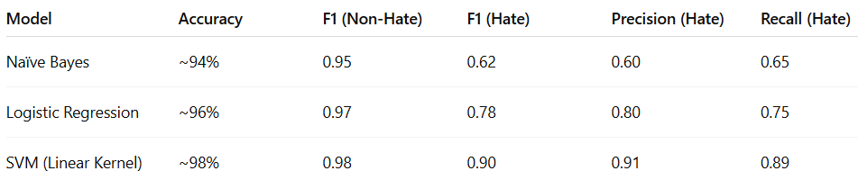

Figure 26: Comparative Performance Summary

## 

Figure 27: Confusion matric Naive Bayes Classifier

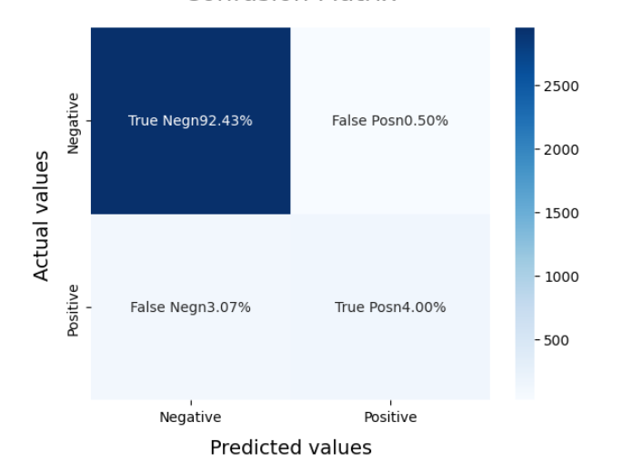

Figure 28: Confusion matrix SVM

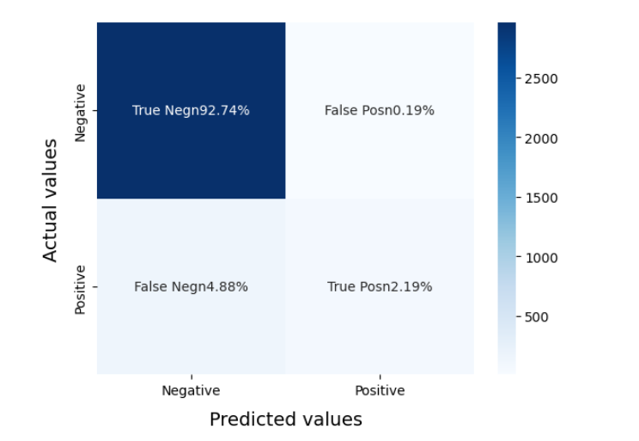

Figure 27: Confusion matrix Logistic Regression

## 7. Conclusion and Future scope

This project set out to explore the use of machine learning techniques for sentiment analysis of Twitter data, with a specific focus on the identification of hate speech particularly content involving racism and sexism. As social media becomes a dominant medium for communication and expression, the need for robust systems to monitor and moderate harmful content has grown substantially. Through the careful implementation of preprocessing, feature extraction, model training, and evaluation, this project has successfully demonstrated how machine learning can be leveraged to build a sentiment classification system that is both efficient and reliable.

At the heart of this system lies the transformation of raw text data into meaningful insights. Starting from a real-world dataset of tweets obtained from Kaggle, we cleaned and prepared the data using industry-standard techniques. This involved removing stop words, symbols, links, punctuation, and other irrelevant noise, and applying text normalization techniques like stemming and lemmatization. The clean data was then converted into a structured, numerical format using TF-IDF vectorization, which captured the relative importance of words across the dataset. This process significantly improved the signal-to-noise ratio and allowed traditional machine learning models to operate effectively on high-dimensional input.

Three machine learning models were then implemented: Naïve Bayes, Logistic Regression, and Support Vector Machine (SVM). Each model was trained using a balanced dataset of 6,000 tweets and evaluated based on key performance metrics: accuracy, precision, recall, and F1-score. The comparative analysis revealed distinct strengths and limitations for each classifier. Naïve Bayes, while fast and interpretable, struggled to accurately identify hate speech, likely due to its strong assumption of word independence. Logistic Regression offered a more balanced performance with decent recall and precision, making it suitable for general-purpose sentiment applications. However, SVM outperformed both, exhibiting superior performance in terms of precision, recall, and overall classification reliability.

What truly sets this project apart is the depth of analysis in each phase. Evaluation was not limited to raw metrics; confusion matrices and visualization tools were used to understand exactly where and why models failed. This holistic approach provided insights into model behavior, reinforced the importance of data quality and balance, and highlighted the sensitivity of the problem domain. Importantly, the project emphasizes the ethical implications of sentiment analysis. A false negative in hate speech detection is not just a misclassification; it can contribute to the spread of harmful rhetoric. This understanding drove our focus on not just accuracy but also recall and fairness.

In conclusion, this project proves that machine learning, when applied thoughtfully and responsibly, can play a significant role in detecting hate speech and enhancing online safety. By combining technical rigor with ethical awareness, we have laid the groundwork for a practical solution that could be extended, scaled, and deployed across social media platforms to aid in content moderation, public sentiment tracking, and research.

While the outcomes of this project are promising, there are several avenues for future improvement and expansion. Sentiment analysis, particularly in the realm of hate speech detection, is an evolving field that must keep pace with linguistic diversity, evolving cultural contexts, and the increasingly sophisticated ways in which harmful speech can manifest online. The models and methods implemented here provide a strong foundation, but more advanced techniques and broader datasets could further enhance performance and applicability.

One of the most promising areas for future development lies in the use of deep learning and transformer-based architectures, such as BERT (Bidirectional Encoder Representations from Transformers). These models are capable of capturing semantic meaning and contextual relationships far more effectively than traditional TF-IDF vectorization. By fine-tuning BERT on domain-specific Twitter data, we can enable the classifier to understand slang, sarcasm, and polysemous words that are often prevalent in hate speech. This would also help address the shortcomings of feature independence assumptions made by simpler models.

Another important direction is the inclusion of multilingual and code-switcheddata. Hate speech is not confined to English, and in many cases, users employ multiple languages or alternate between them in a single tweet. Future systems must be able to process multilingual inputs, either through translation pipelines or multilingual embeddings, to effectively monitor content from global audiences.

Improving the granularity of classification is another avenue worth exploring. Rather than binary labels (hate vs. non-hate), future models could adopt multi-classor multi-label classification, identifying not just whether a tweet is hateful, but what kind of hate it represents (racism, sexism, homophobia, etc.). This would provide more actionable insights for policymakers, researchers, and platform moderators. Combined with severity scoring (e.g., mild, moderate, severe), such a system could facilitate proportional responses.

In summary, this project lays a solid foundation for sentiment analysis using machine learning. The future holds vast potential, from technical enhancements and real-time deployment to expanded language support and ethical innovation. By continuing to build upon this work, we can develop more accurate, inclusive, and ethical AI systems that help create safer, more respectful digital environments.

## References

## [1] Twitter Sentiment Analysis

[https://www.kaggle.com/datasets/arkhoshghalb/twitter-sentiment-analysis-hatred-speech/data](https://www.kaggle.com/datasets/arkhoshghalb/twitter-sentiment-analysis-hatred-speech/data%20)

[2] Sentiment analysis using Twitter data: a comparative application of lexicon- and machine-learning-based approach.

<https://link.springer.com/article/10.1007/s13278-023-01030-x>

[3] Twitter Sentiment Analysis Using Python: Introduction & Techniques

[link](https://www.analyticsvidhya.com/blog/2021/06/twitter-sentiment-analysis-a-nlp-use-case-for%20beginners/#:~:text=Assigning%201%20to%20Positive%20sentiment,tail()%20Copy%20Code)

[4] Twitter Sentiment Analysis using Python

<https://www.geeksforgeeks.org/twitter-sentiment-analysis-using-python/>

[5] Sentiment analysis of twitter data using machine learning approaches and semantic analysis

<https://ieeexplore.ieee.org/document/6897213>

[6] Twitter sentiment analysis [link](https://www.researchgate.net/publication/379118930_Sentiment_Analysis_of_Twitter_Data_Using_Machine_Learning_Techniques#:~:text=Twitter%20sentiment%20analysis%20examines%20the,73.&text=Content%20may%20be%20subject%20to%20copyright.&text=Content%20may%20be%20subject%20to%20copyright.,-International%20Journal%20of&text=This%20work%20is%20licensed,Attribution%204.0%20International%20License.&text=various%20social%20media%20platforms%20about%20ongoing%20global%20events.,-On%20controversia&text=gives%20highest%20accuracy%20of,73.&text=sentiment%20analysis%20on%20Twitter%20using%20NLP%20methodologies.)